**Project Report on**

**Detecting Fire combustion in forest using IBM Watson Studio**

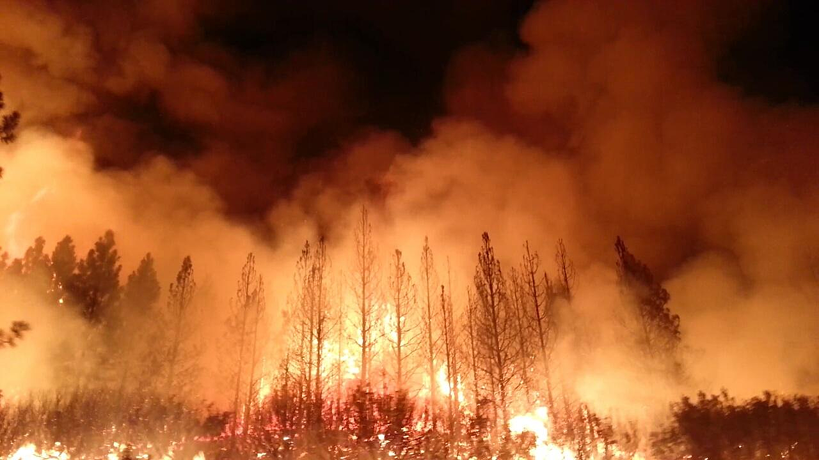

**Done by :**

**UTKARSH PARIVESH BOHRA**

**Manipal Academy of Higher Education - Dubai Campus**

**TABLE OF CONTENT**

|  |  |  |
| --- | --- | --- |
| Sr.No. | Topic | Page No. |
| 1 | Abstract | 3 |
| 2 | Introduction | 4 |
| 3 | Literature Review | 5 |
| 4 | Flow Chart | 6 |
| 5 | System Requirements | 7 |
| 6 | Experimental Results | 8 |
| 7 | Experimental Analysis | 10 |
| 8 | Advantages & Disadvantages of CNN | 11 |
| 9 | Future Scope | 12 |
| 10 | Conclusion | 13 |

**Abstract**

Every year millions of hectares of forest are destroyed by fire. When forest fuels burns, there is a chemical combination of the oxygen in the air with woody material, pitch and other burnable elements found in the forest environment. Every year in America itself, there are one lakh wildfires which destroy over nine million acres of land.

Forest Fire Detection is very important. Monitoring of the potential risk areas and early detection of fire can significantly shorten the reaction time and also reduce the potential damage as well as the cost of fire fighting.

As we all know that wild fires can't be eradicated completely so IBM Watson Studio uses Artifical Intelligence and Machine Learning to detect fires and fight fires more quickly and efficient and help alert the firefighters and community. I have used Watson Studio to train my Convolution Neural Network (CNN), test the model , deploy the model on Watson Studio .

Thus technology can play a major role in improving the response and management of fires.

**Introduction**

Forest fires are occuring throughout the year with an increasing intensity in the summer and autumn season and usually causes devastating damage to both nature and human.Forest fires are mainly caused by human actions, lightning strikes, spontaneous combustion of dried leaves or saw dust, etc. and are considered as a main contribution to the air pollution. To fight forest fires different solutions were employed throughout the years were primarily aimed at early detection of fires.

The constant evaluation of information and communication technology has led to the introduction of a new generation of solution for early detection and prevention of forest fires like Deployment of Machine Learning model using IBM Watson studio , Application of Convolution Neural Network.

Use of these technologies is much more cost effective and reliable as compared to earlier techniques like use of sensors, ICT based camera network and satellite technology.

It helps in preventing the forest fires by using the above two technologies.

**Literature Review**

Problem Statement : Recently, forest fire disaster are getting much attention throughout the world. Significant causes of forest fires are either human origin or envirnoment origin. Forest fire caused by human beings are may be due to picnic fires, shepherd fire, smoking and throwing cigarettes , sparks in power lines, explosives , fire used during hunting etc. Environment origin forest fires are caused due to lightening strikes which may happen due to high environmental temperature, weather factors like temperature, relative humidity , precipitation of wind speed, rainfall, etc.

Solution : The constant evaluation of information and communication technology has led to the introduction of a new generation of solution for early detection and prevention of forest fires like Deployment of Machine Learning model using IBM Watson studio and Application of Convolution Neural Network.

Implementation of these above mentioned solution will help in early detection of forest fire throughout the world and hence preventing them from spreading further.

**Flow Chart**

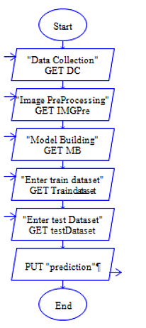

# System Requirement

Software

Jupyter Notebook

Anacoda Navigator

Anacoda Prompt

IBM Cloud Account for Machine Learning Activities

Zoho writer for Document

# Hardware

Processor : Intel Core i7 10510u

Secondary Storage Device =512 GB

**Experimental Results**

Output on Training the model on Local System

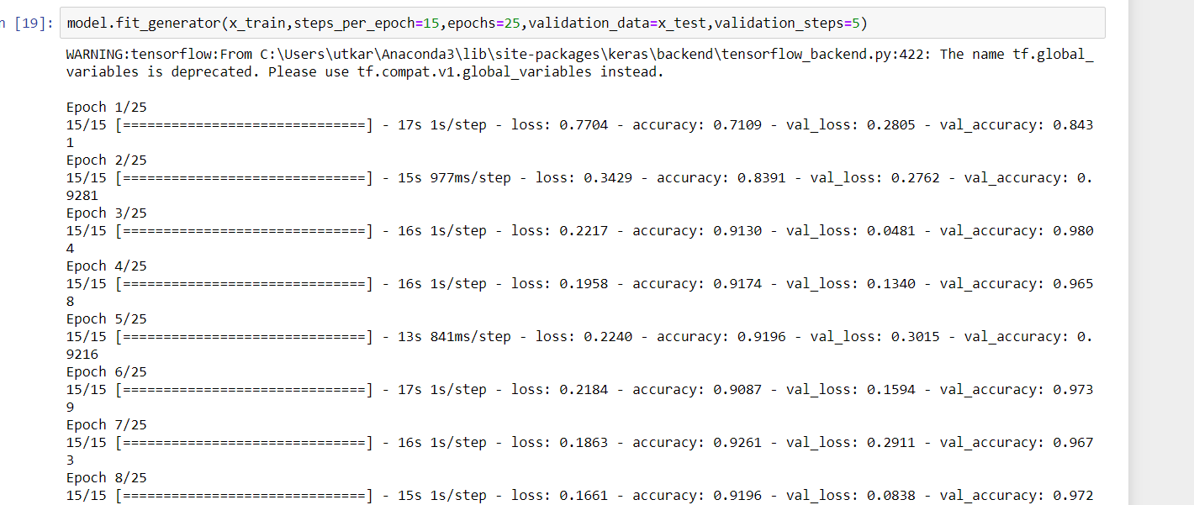

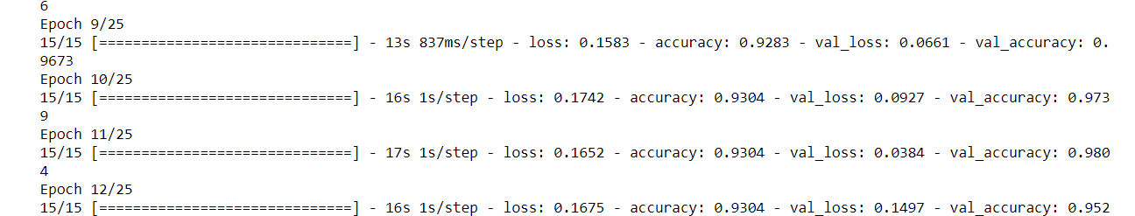

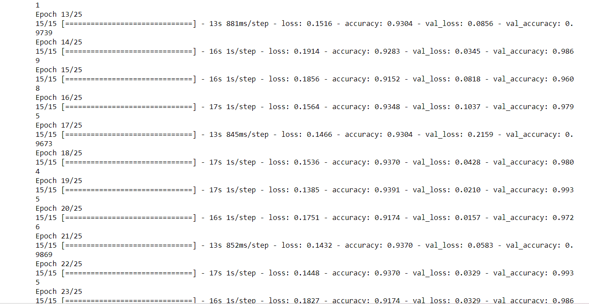

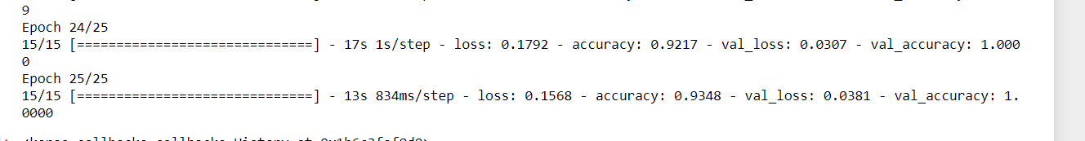

Video Analysis code and output:  
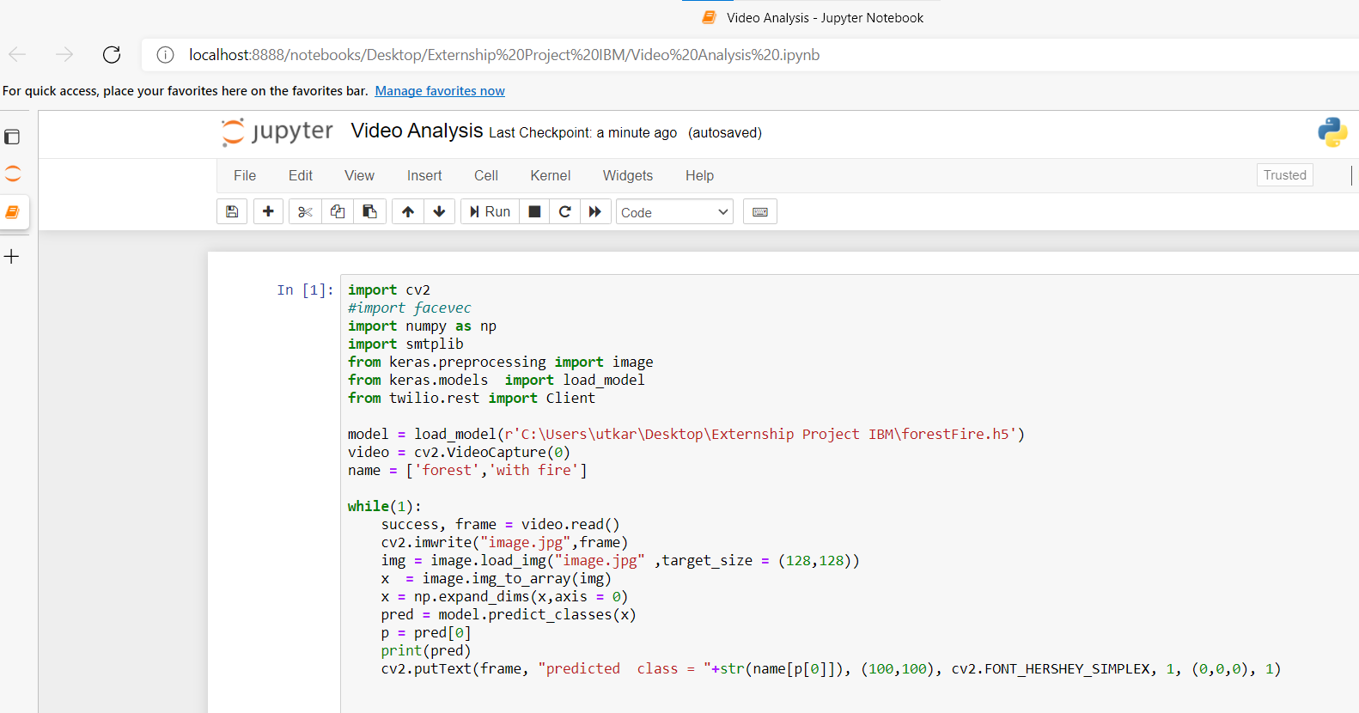

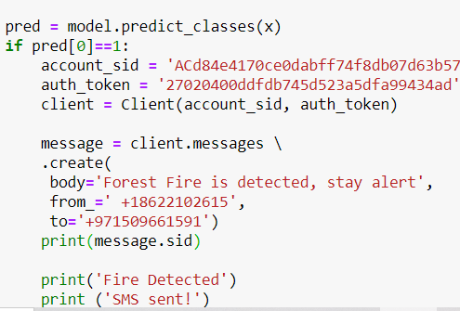

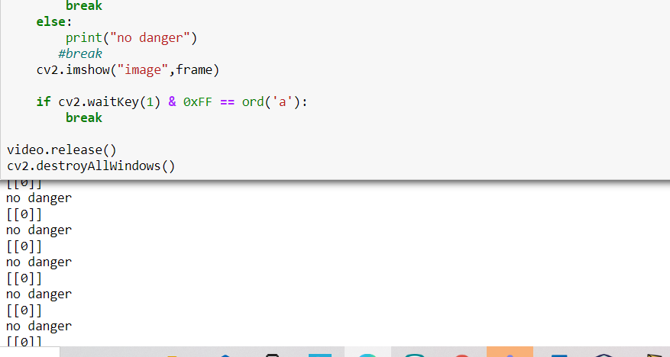

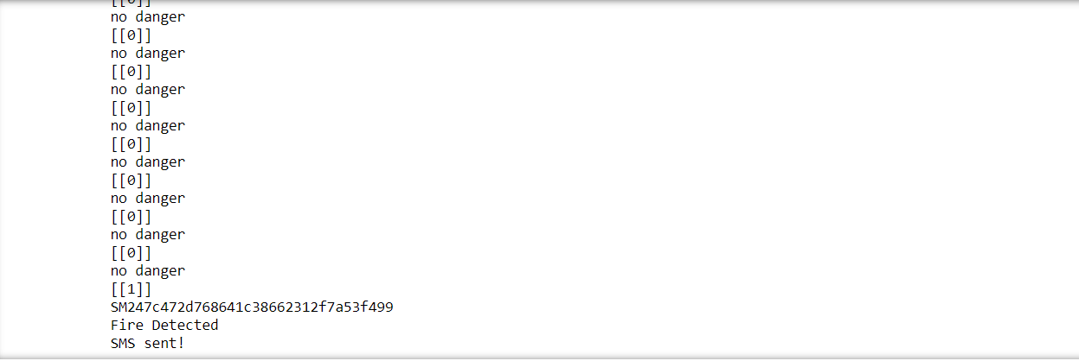

**Experimental analysis**

While developing the machine learning model I was introduced few of the libraries which are a part of data science like tensorflow, keras and opencv for the project purposes. I was also introduced to libraries of numpy,pandas and also to concepts of Artificial Neural Network, Recurrent Neural Network , Convolutional Neural network .

We were also given a lab sessions to understand concepts by giving some lab work on Jupyter notebook.

The main application of this model is to predict the provided image is having forest fire or not. It is well trained so that it will predict the correct data.

**Advantages and Disadvantages of Convolutional Neural Network(CNN)**

**Advantages of CNN:**

1.It automatically detects the important features without any human supervision.

2.Little dependence on preprocessing

3. It is easy to understand and fast to implement.

4. It has the highest accuracy among all the algorithms that predict images.

5. It provide an efficient dense network which perform the prediction or indentification efficiently.

**Disadvantages of CNN:**

1. A Convolutional Neural Network is significantly slower due to an operation such as maxpool.

2. A ConvNet requires a large dataset to process and train the neural network .

3. If the CNN has several layers then the training process takes a lot of time if the computer does not consists of a good Graphical Processing Unit(GPU).

4. Large training data needed

5. Does not encode the position and orientation of object.

**Future Scope**

Artificial Intelligence and Machine Learning can be used to detect forest fires with the focus on day time images and can also identify smoke and flame immediately and thus reducing false positive and time until the fire fighters are called onto the scene.

Secondly a system can be made to detect whether any trees or plants are overgrown or if there too close to power lines.So they can take action immediately and can prevent forest from fires.

**Conclusion**

Forest fires are a major threat to life and property throughout the world and specially in the northern hemisphere where the temperature rises very high in summer and autumn season .Therefore, detection of forest fires at a very early stage is important.

In this project I have used Jupyter notebook, Anaconda prompt, IBM Watson Studio for training and deployment of my model . IBM supports technology and efforts to improve forest fire responses.

Without pre-trained Keras model, the train accuracy is 91.5% and validation accuracy is

90.0%.The validation result had a best figure of 93.48% as accuracy.It is observed that

without using pre-trained Keras model, although the training accuracy is >90%, the overall

accuracy is low unlike where pre-trained model is used.